17/10/07

SHORT COURSE

MANAGEMENT SYSTEM

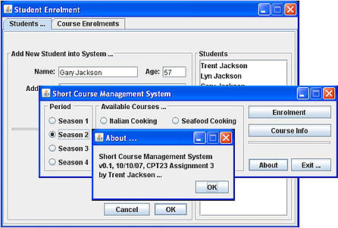

Revision: 0.02 (GUI-based)
Platform: Windows / Mac / Linux
Language: Java
License: Public domain
Release date: 17/10/07
Dependencies: Java runtime 1.5 or higher

Launching the software ……………...……………………………………3
Using the software ……………...……………………………………….…3
Adding a new student ……………...………………………………...……4
Withdrawing a student ……………...……………………………….……4
Enrolling a student in a course ………..…………..………………………5
Displaying course figures …………………………………………….……6
Discount policies & subsidy ………….………………...…………….……6

Launching The Software

The GUI-based system is executed at command line level. Windows users should type the following at the command prompt …

- C:\>Java Short_Course_Management

Using The Software …

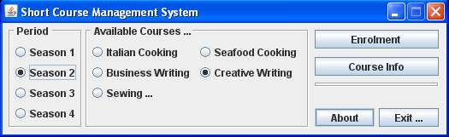

Fig. 1: Main Menu

Fig.1 depicts a screen grab of the main menu that should greet you when it’s first launched. The menu consists of 9 options, 5 courses x 4 seasons, and two functions enrolment and course info (the financial statistics) By default, when the program first launches, season 1 and Italian cooking are automatically selected. Clicking on either of the two function buttons: enrolment or course info brings up a new window containing the required function for the user to perform their intended task on the currently selected course and season…

It is imperative that this main menu closes gracefully at the end of each session. Before actual termination occurs, it needs to write all of the student details and list of course enrolments to a flat-file database. Clicking on the “exit button” or closing the window manually will normally result in a successful file saving operation before termination.

Adding & Removing a Student
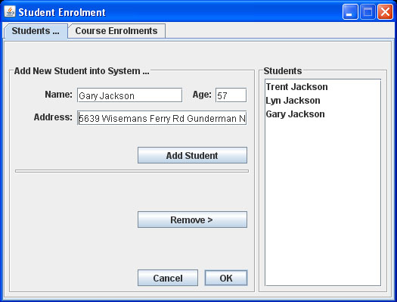

Fig. 2: Add student tab

Clicking on the “enrolments” button on the main menu brings up the screen as shown in above. This frame consists of two tabs, students and enrolments. Students need to be listed on the system before they can be actually enrolled in any course. To do this, click on the “students” tab and then key in the required fields - name, age & address. Be aware, the system will reject any incomplete entries. After these details have been entered, simply click on the “add student” button, their name will now appear in the list.

Removing a student is just as easy. First locate their name in the list, click on it to select and then just click on the “remove” button located directly below “add student”. However, before any changes are actually saved, the “OK” button needs to be clicked. Clicking on “Cancel” will restore the list of students to its previous state.

Enrolling a Student in a Course
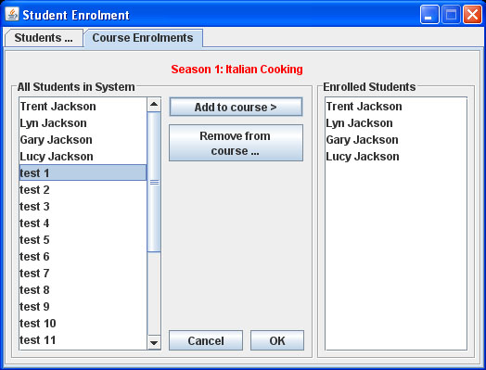

Fig.2: Course enrolments tab

To enroll a student in the selected course, this is simply a matter of locating their name in the system (list box far left side) – click on their name to select it, then click on “add to course” to complete the operation. Now their name will be listed in the enrolled students list, located far right of GUI. To remove a student, we need to select their name in the enrolled students list followed by clicking on the “remove from course” button. After all students have been added / removed, click on “OK” to save changes, otherwise click on cancel to restore the enrolment list to its prior state.

A number of failsafe measures have been implemented to ensure the system’s integrity. The system will reject an enrolment if:

1. They already exist (this season, this course)
2. The class is full
3. No student name has been selected

Displaying Course Figures
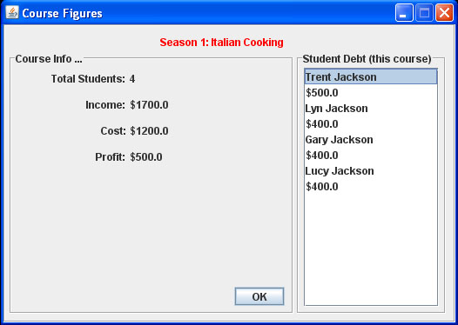

Fig. 2: Course Figures

Clicking on the “course info” button in the main menu will bring up a screen like the one shown above. This screen, like the rest of them is fairly simple and incredibly quite self-explanatory. One interesting aspect of this system is that, student debts are not stored anywhere! There’s absolutely no trace of them. Instead, the system implements what I like to call “information on demand” Perhaps a very daunting task for many procedural languages, but not for Java! Thanks to the magic of OOP, the system is able to quickly & easily tally up the course figures “on the fly” when needed.

Discount Polices & Subsidy

- Students aged 50 & over receive $100 off
- Students enrolled in two or more courses receive 20% off
- Seafood cooking & business writing courses receive a $200 subsidy from the local government, if there are more than 10 enrolments.

*These rules are unfortunately hard-coded in the system. If only there was 30hrs in a day.

